NLCC #17 Cougar

Uniform Sizing Information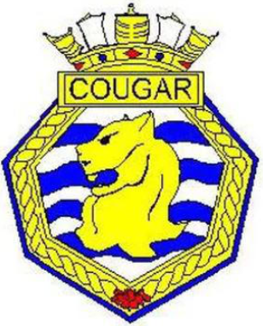

Last Name: First Name:
Male □ Female □
Cadet’s Measurements in inches
Head:________________________
Neck: ________________________
Chest:________________________
Waist:________________________
Hips:_________________________
Height:_______________________
Shoe Size:____________________

Note: Uniforms are issued as a loan to the cadet at no cost.

