NLCC #17 Cougar

Cadet Communication, Information and Local Unit Consent
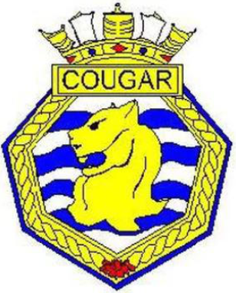

Cadet Last Name: First Name:

Image use- Optional
"The Canadian Forces, the Navy League, Navy League - Hamilton Branch and local sponsors may, at any time, use and disclose photographic images and video footage of a cadet, as well as his/her name, age, home unit name and location, and accomplishments, through print and electronic media, for the purposes of publicly recognizing his/her accomplishments and promoting the Corps as well as their programmes."
□ I consent □ I do not consent
Parent Signature: Date:
Parent Name:
Google Groups:
If you would like to join our Google group to keep informed as to upcoming activities and events please provide your email address below. You may opt out at any time using Google groups.
email address:
How did you learn about Cougar?
□ Online □ Facebook □ Friend/Family □ I was a Cadet □ Community Board
□ Other

